Prayer after Communion
Eternal God, we give you thanks for this holy mystery in which you have given yourself to us. Make us ever faithful to your high calling of love and justice. Grant that we may go into the world in the strength of your Spirit, to give ourselves for others. In the name of Jesus Christ our Lord. Amen
*Singing Our Faith # 176 “Majesty, Worship His Majesty”
*Blessing and Dismissal
*Postlude

Scatter to Serve God & Neighbor

Welcome to all! We gather to praise God for the innumerable blessings given

to us and to grow deeper in the Spirit. Joyfully, let us lift our hearts to God.



DIRECTORY OF CHESTNUT HILL UNITED METHODIST CHURCH
Sharma Lewis | Richmond Area Resident Bishop
Denise Bates | Mountain View District Superintendent
Adam White | Minister
Erin Long | Associate Minister
Monica Campbell | Administrative Assistant
Heather Wilson | Director of Music Ministry
Judy Martin | Bookkeeper
Judy Robertson | Lay Leader


Chestnut Hill
United Methodist Church

Making disciples of Jesus Christ
for the transformation of the world.
You are welcome at Chestnut Hill UMC.

4660 Fort Avenue ~ Lynchburg, Virginia 24502
Church: 434-239-8423
Minister’s Cell: 434-944-7723, Minister’s Email: awhite@ves.org
Associate Minister’s Cell: 1-502-489-0200
Associate Minister’s Email: healingsolutions12@gmail.com
chestnuthillumc@comcast.net ~ on the web at chestnuthillumc.net
Find us on Facebook: Chestnut Hill United Methodist Church

Chestnut Hill United Methodist Church
10:30 a.m. ~ September 4, 2022 ~ Thirteenth Sunday after Pentecost
Our ministry vision for the Virginia Annual Conference is “to be disciples of Jesus Christ who are lifelong learners, who influence others to serve.”

Welcome! Join us in worshiping God!

Prelude
Welcome and Ministry Announcements
Welcome in the name of Christ our Lord. Please register your attendance,
printing your name, address, phone, and email, on the attendance pad provided on your pew. Thank you for silencing cell phones as we gather to worship God.
Invocation
Greeting
Lord, let me live from day to day,
In such a self-forgetful way,
That even when I kneel to pray,
My prayer shall be for others.
Yes, others, Lord, yes, others,
Let this my motto be;
Help me to live for others,
That I may live like Thee. (Charles D. Meigs, 1917)
*Singing Our Faith # 57 (vs. 1 ,2, 3, 4 & 6) “O For a Thousand Tongues to Sing”

*Opening Prayer
Grant us, O Lord, to trust in you with all our hearts; for, as you always resist the proud who confide in their own strength, so you never forsake those who make their boast of your mercy; through Jesus Christ our Lord, who lives and reigns with you and the Holy Spirit, one God, now and for ever. Amen.

Greeting Friends and Neighbors
Prayer for Illumination
Gracious God, we do not live by bread alone, but by every word that
comes from your mouth. Make us hungry for this heavenly food, that it
may nourish us today in ways of eternal life; through Jesus Christ, the
bread of heaven. Amen.
Scripture Lesson Luke 14:25-33
The Word of God for the people of God.

Thanks be to God.
Singing Our Faith # 382 “Have Thine Own Way, Lord”
The Good News “Walking the Tightrope”
Invitation ~ page 12
Confession and Pardon

Bringing Forward God’s Tithes and Our Gifts
*Doxology # 95 Praise God from whom all blessings flow; praise him, all
Creatures here below; praise him above, ye heavenly host; praise Father, Son, and Holy Ghost. Amen.
*Prayer of Thanksgiving
Sharing of Joys and Concerns
The Great Thanksgiving ~ page 13
The Lord’s Prayer

Our Father, who art in heaven, hallowed be thy name. Thy kingdom come,
Thy will be done on earth as it is in heaven. Give us this day our daily bread and forgive us our trespasses, as we forgive those who trespass against us. And lead us not into temptation, but deliver us from evil. For thine is the kingdom, and the power, and the glory, forever. Amen.
Taking the Bread and the Cup

**Calendar**
Monday, 9/5 |  | Labor Day ~ Church Office Closed
Tuesday, 9/6 | 6:30 p.m. | Homeschool Game Night
Friday, 9/9 | 10:00 a.m. | Homeschool
**Looking Ahead on the Calendar **
Monday. 9/12 | 7:00 P.M. | Wesleyan Group  Meeting at home of Ann Robbins.
Tuesday, 9/13 | 6:30 p.m. | Staff-Parish Relations Committee
Wednesday, 9/14 | 10:00 a.m. | Merry Martha’s @ Church  UMW Pledge and lunch at Charley’s

Hospital: Lynchburg General: Gene Pearson, Beryl Martin


For the Grocery Cart:

September ~ Canned Meat and Canned Fruit (Including Ravioli)
Place donations in the grocery cart, located in the Commons.
No “baked goods” of any kind!

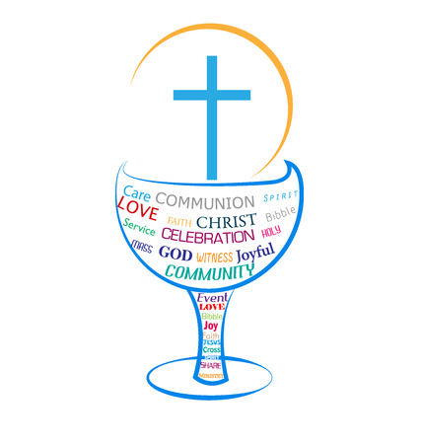

**Calendar**
Monday, 9/5 |  | Labor Day ~ Church Office Closed
Tuesday, 9/6 | 6:30 p.m. | Homeschool Game Night
Friday, 9/9 | 10:00 a.m. | Homeschool
**Looking Ahead on the Calendar **
Monday. 9/12 | 7:00 P.M. | Wesleyan Group  Meeting at home of Ann Robbins.
Tuesday, 9/13 | 6:30 p.m. | Staff-Parish Relations Committee
Wednesday, 9/14 | 10:00 a.m. | Merry Martha’s @ Church  UMW Pledge and lunch at Charley’s

Hospital: Lynchburg General: Gene Pearson, Beryl Martin

For the Grocery Cart:

September ~ Canned Meat and Canned Fruit (Including Ravioli)
Place donations in the grocery cart, located in the Commons.
No “baked goods” of any kind!

